**ATNT laboratories**

1. **Import & Distribution services**
2. **Breeding services**
3. **CRO services**
4. **Import & Distribution services**
5. **Breeding services**

Our Breeding Services make it easy and inexpensive to manage your mouse colonies. We'll make sure you get the mice you need, when you need them.

* **Various mice strains to be available at Hyderabad site include:**

1. C57BL/6J
2. NU/J
3. BALB/cJ
4. NOD.Cg-*Prkdcscid*/J
5. J:ARC(S)
6. **C57BL/6J**

Strain number: **000664**

Common Name: **B6**; Also known as: **B6J, B6/J**

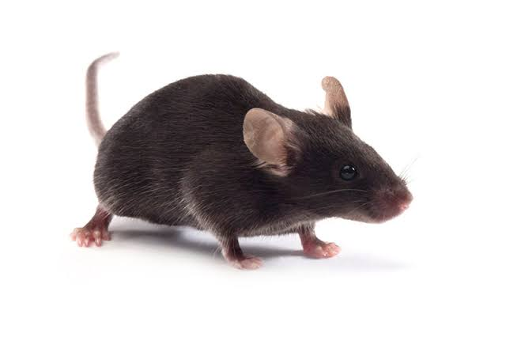

* C57BL/6J is the most widely used inbred strain and the first to have its genome sequenced.
* They are commonly used in the production of transgenic mice.
* They breed well, are long-lived, and have a low susceptibility to tumours.
* Although this strain is refractory to many tumours, it is a permissive background for maximal expression of most mutations.
* C57BL/6J mice are used in a wide variety of research areas including cardiovascular biology, developmental biology, diabetes and obesity, genetics, immunology, neurobiology, and sensorineural research.
* This mice strain is resistant to audiogenic seizures, have a relatively low bone density, and develop age related hearing loss. They are also susceptible to diet-induced obesity, type 2 diabetes, and atherosclerosis.
* Macrophages from this strain are resistant to the effects of anthrax lethal toxin.

**Price details\***

**Body weight information\***

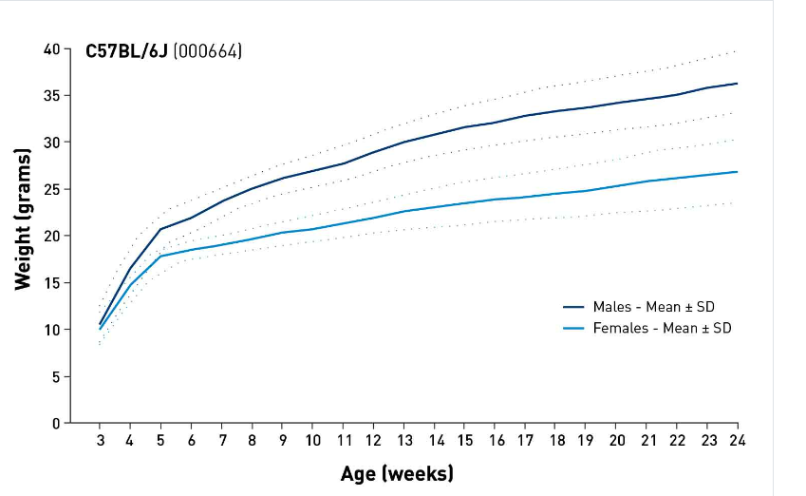

|  |  |  |  |  |
| --- | --- | --- | --- | --- |
| **AGE** | **Female** | | **Male** | |
| **Import price** | **Indian price** | **Import price** | **Indian price** |
| 3 Weeks | $40.94 |  | $37.09 |  |
| 4 Weeks | $42.17 |  | $38.57 |  |
| 5 Weeks | $45.18 |  | $44.17 |  |
| 6 Weeks | $46.49 |  | $45.42 |  |
| 7 Weeks | $49.13 |  | $48.92 |  |
| 8 Weeks | $50.56 |  | $50.38 |  |
| 9 Weeks | $56.20 |  | $55.06 |  |
| 10 Weeks | $66.55 |  | $65.91 |  |

|  |  |  |
| --- | --- | --- |
| **Age (Weeks)** | **Body Weight (grams; mean± st. dev)** | |
| **Females** | **Males** |
| 3 | 10.1 ± 1.7 | 10.6 ± 1.9 |
| 4 | 14.7 ± 1.8 | 16.5 ± 2.6 |
| 5 | 17.8 ± 1.1 | 20.7 ± 1.8 |
| 6 | 18.5 ± 0.9 | 21.9 ± 1.8 |
| 7 | 19.0 ± 1.0 | 23.6 ± 1.5 |
| 8 | 19.6 ± 1.2 | 25.0 ± 1.4 |
| 9 | 20.3 ± 1.3 | 26.1 ± 1.6 |
| 10 | 20.7 ± 1.4 | 26.9 ± 1.7 |
| 11 | 21.3 ± 1.5 | 27.7 ± 1.9 |
| 12 | 21.9 ± 1.6 | 28.9 ± 2.0 |
| 13 | 22.6 ± 1.9 | 30.0 ± 2.1 |
| 14 | 23.0 ± 2.0 | 30.8 ± 2.2 |
| 15 | 23.5 ± 2.3 | 31.6 ± 2.4 |
| 16 | 23.9 ± 2.3 | 32.1 ± 2.4 |
| 17 | 24.1 ± 2.5 | 32.8 ± 2.6 |
| 18 | 24.5 ± 2.6 | 33.3 ± 2.8 |
| 19 | 24.8 ± 2.8 | 33.7 ± 2.8 |
| 20 | 25.3 ± 2.8 | 34.2 ± 2.9 |
| 21 | 25.8 ± 3.2 | 34.6 ± 2.9 |
| 22 | 26.1 ± 3.2 | 35.1 ± 3.2 |
| 23 | 26.5 ± 3.3 | 35.8 ± 3.2 |
| 24 | 26.9 ± 3.4 | 36.3 ± 3.4 |

**\*** Price details and body weight information mentioned above are as per US considerations and Indian data is yet to be updated.

1. **NU/J**

Strain number: **002019**

Common Name: **nude;** Also known as: **athymic nude**

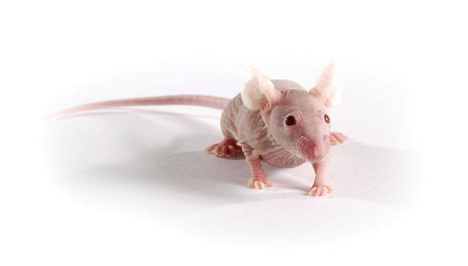

* Nude mice are the inbred strain.
* The two main defects of mice, homozygous for the nude spontaneous mutation (Foxn1nu, formerly Hfh11nu) are abnormal hair growth and defective development of the thymic epithelium.
* Nude mice are also athymic caused by a developmental failure of the thymic anlage, consequently lack T cells and suffer from a lack of cell-mediated immunity.
* Homozygous nude mice show partial defect in B cell development probably due to absence of functional T cells.
* Other endocrine and neurological deficiencies have also been reported in this strain.
* The use of nude mice has reduced the number of thymectomy procedures required in research projects.
* Nude mice are used in a variety of research conditions including [T-cell immunodeficiency, congenital alopecia, nail dystrophy and DiGeorge syndrome.](http://www.informatics.jax.org/disease/DOID:0060769)
* Homozygous nude females are not effective breeders as ovulation starts late at 2.5 months and ends early at 4 months of age.

**Price details\***

**Heterozygous for Foxn1<nu>**

|  |  |  |  |  |
| --- | --- | --- | --- | --- |
| **AGE** | **Female** | | **Male** | |
| **Import price** | **Indian price** | **Import price** | **Indian price** |
| 3 Weeks | $79.68 |  | $78.51 |  |
| 4 Weeks | $79.68 |  | $78.51 |  |
| 5 Weeks | $78.48 |  | $78.51 |  |
| 6 Weeks | $84.03 |  | $82.81 |  |
| 7 Weeks | $87.14 |  | $85.89 |  |
| 8 Weeks | $92.74 |  | $91.39 |  |

**Homozygous for Foxn1<nu>**

|  |  |  |  |  |
| --- | --- | --- | --- | --- |
| **AGE** | **Female** | | **Male** | |
| **Import price** | **Indian price** | **Import price** | **Indian price** |
| 3 Weeks | $80.44 |  | $78.51 |  |
| 4 Weeks | $80.44 |  | $78.51 |  |
| 5 Weeks | $80.44 |  | $78.51 |  |
| 6 Weeks | $84.86 |  | $82.81 |  |
| 7 Weeks | $89.31 |  | $87.17 |  |
| 8 Weeks | $93.65 |  | $93.65 |  |

**Body weight information\***

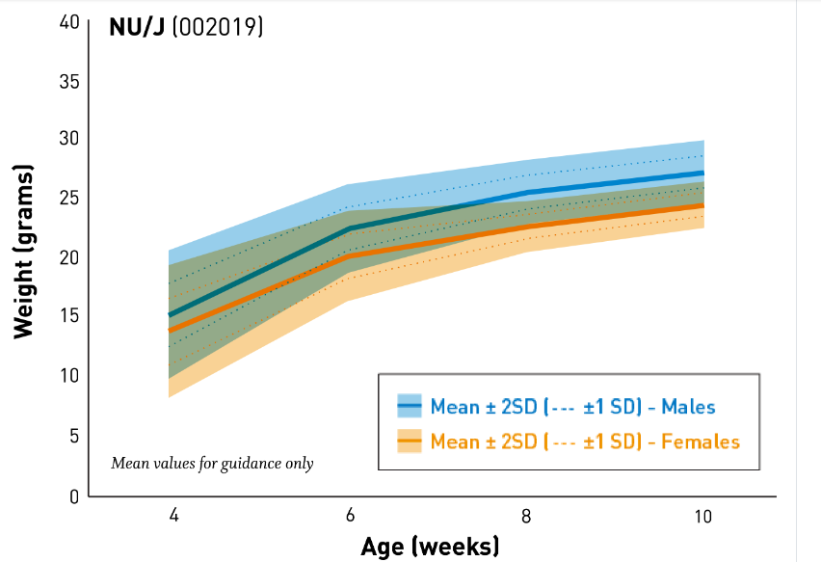

|  |  |  |  |  |
| --- | --- | --- | --- | --- |
| **Body Weight (grams; mean± st. dev)** | | | | |
| **Age (Weeks)** | **Females** | | **Males** | |
| **Homozygous** | **Heterozygous** | **Homozygous** | **Heterozygous** |
| 3 | 9.9 ± 2.8 | 15.6 ± 3.1 | 10.8 ± 2.2 | 16.6 ± 3.3 |
| 4 | 15.8 ± 3.2 | 21.2 ± 2.5 | 18.1 ± 2.7 | 23.7 ± 2.5 |
| 5 | 19.9 ± 1.8 | 23.3 ± 2.0 | 23.1 ± 1.5 | 27.3 ± 2.2 |
| 6 | 21.0 ± 1.9 | 24.7 ± 2.2 | 24.8 ± 1.5 | 30.0 ± 2.0 |
| 7 | 22.5 ± 1.5 | 25.2 ± 2.1 | 26.9 ± 1.5 | 30.5 ± 3.0 |
| 8 | 23.7 ± 1.2 | 26.4 ± 2.1 | 27.6 ± 1.4 | 32.7 ± 2.4 |
| 9 | 23.8 ± 1.3 | 27.3 ± 1.4 | 28.0 ± 1.6 | 34.7 ± 2.1 |
| 10 | 24.7 ± 1.4 | 27.8 ± 2.3 | 28.7 ± 1.8 | 35.2 ± 2.2 |

**\*** Price details and body weight information mentioned above are as per US considerations and Indian data is yet to be updated.

1. **BALB/cJ**

Strain number: **000651**

Common Name:**BALBc;** Also known as:**C, BALB, BALB/c**

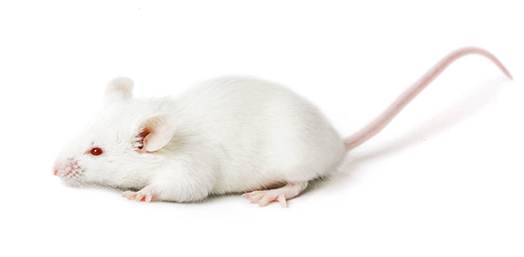

* BALB/cJ is a commonly used inbred sub strain.
* Key traits include susceptibility to developing the demyelinating disease upon infection with Theiler's murine encephalomyelitis virus.
* Rare spontaneous myoepitheliomas arising from myoepithelial cells of various exocrine glands have been observed in this sub strain.
* The BALB/cJ sub strain is susceptible to *Listeria*, all species of *Leishmania*, and several species of *Trypanosoma*, but is resistant to experimental allergic orchitis (EAO).
* **Price details\***

|  |  |  |  |  |
| --- | --- | --- | --- | --- |
| **AGE** | **Female** | | **Male** | |
| **Import price** | **Indian price** | **Import price** | **Indian price** |
| 3 Weeks | $41.17 |  | $35.33 |  |
| 4 Weeks | $42.29 |  | $36.75 |  |
| 5 Weeks | $45.51 |  | $41.60 |  |
| 6 Weeks | $46.44 |  | $42.64 |  |
| 7 Weeks | $51.43 |  | $48.36 |  |
| 8 Weeks | $51.99 |  | $49.34 |  |
| 9 Weeks | $54.44 |  | $50.77 |  |
| 10 Weeks | $62.87 |  | $53.87 |  |

**Body weight information\***

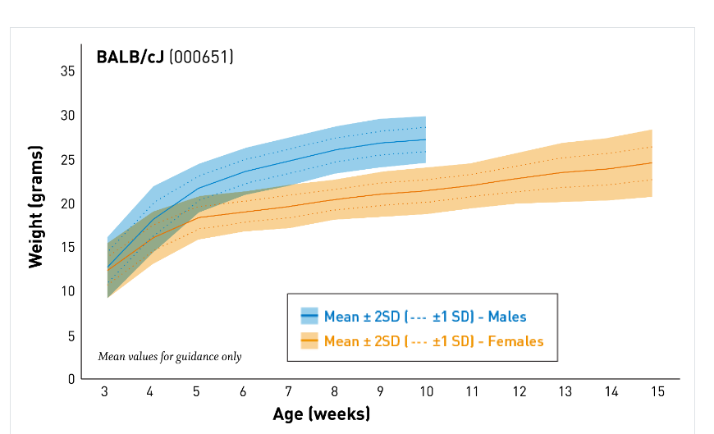

|  |  |  |
| --- | --- | --- |
| **Age (Weeks)** | **Body Weight (grams; mean± st. dev)** | |
| **Females** | **Males** |
| 3 | 12.3 ± 1.6 | 12.7 ± 1.8 |
| 4 | 16.1 ± 1.5 | 18.2 ± 1.9 |
| 5 | 18.4 ± 1.3 | 21.8 ± 1.4 |
| 6 | 19.1 ± 1.2 | 23.7 ± 1.4 |
| 7 | 19.7 ± 1.3 | 24.9 ± 1.4 |
| 8 | 20.5 ± 1.2 | 26.2 ± 1.4 |
| 9 | 21.1 ± 1.3 | 27.0 ± 1.4 |
| 10 | 21.5 ± 1.3 | 27.4 ± 1.4 |
| 11 | 22.1 ± 1.3 | - |
| 12 | 22.9 ± 1.5 | - |
| 13 | 23.6 ± 1.7 | - |
| 14 | 24.0 ± 1.8 | - |
| 15 | 24.7 ± 1.9 | - |

**\*** Price details and body weight information mentioned above are as per US considerations and Indian data is yet to be updated.

1. **NOD.Cg-Prkdcscid/J**

Strain number: **001303**

Common Name: **NOD scid**; Also known as: **NOD SCID**

* Mice homozygous for the severe combined immune deficiency spontaneous mutation *Prkdcscid*, commonly referred to as *scid*, are characterized by an absence of functional T cells and B cells, lymphopenia, hypogammaglobulinemia, and a normal hematopoietic microenvironment.
* *Prkdcscid* mice accept allogeneic and xenogeneic grafts making them an ideal model for cell transfer experiments.
* Some *scid* mice will spontaneously develop partial immune reactivity.

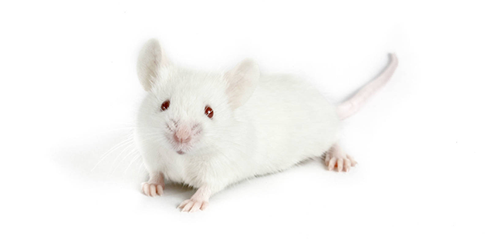

* *scid* mice that have serum Ig levels greater than 1 ug/ml are considered "leaky". *scid* leakiness is highly strain dependent, increases with age, and is higher in mice housed under non-SPF conditions. In general, *Prkdcscid* leakiness is low on the NOD/ShiLtSz genetic background.
* *Scid* mice carry a DNA repair defect and a defect in the rearrangement of genes that code for antigen-specific receptors on lymphocytes.
* Thymic lymphomas occur with high frequency in this strain.
* The life span is typically limited to only 8.5 months under specific pathogen-free conditions.

**Price details\***

|  |  |  |  |  |
| --- | --- | --- | --- | --- |
| **AGE** | **Female** | | **Male** | |
| **Import price** | **Indian price** | **Import price** | **Indian price** |
| 3 Weeks | $149.03 |  | $147.56 |  |
| 4 Weeks | $149.03 |  | $147.56 |  |
| 5 Weeks | $153.62 |  | $152.15 |  |
| 6 Weeks | $158.20 |  | $156.73 |  |
| 7 Weeks | $162.79 |  | $161.32 |  |
| 8 Weeks | $167.38 |  | $165.89 |  |
| 9 Weeks | $171.96 |  | N/A |  |
| 10 Weeks | $176.55 |  | N/A |  |

**Body weight information\***

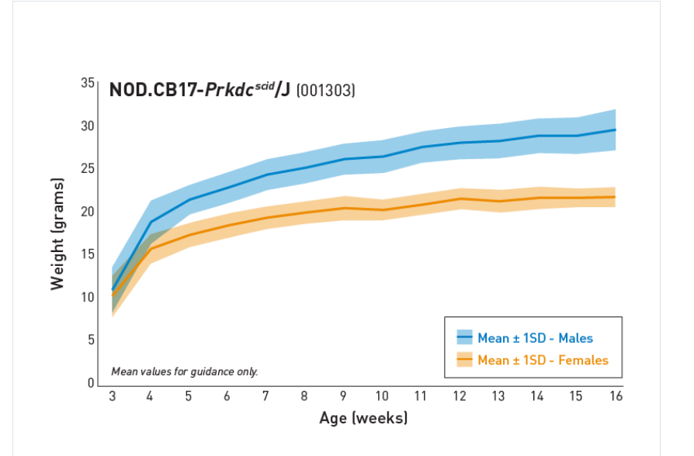

| **Age (weeks)** | | 3 | 4 | 5 | 6 | 7 | 8 | 9 | 10 |
| --- | --- | --- | --- | --- | --- | --- | --- | --- | --- |
| **Male** | **Mean** | 11.1 | 19.0 | 21.6 | 23.0 | 24.5 | 25.3 | 26.6 | 26.3 |
| **St Dev** | 2.6 | 2.5 | 1.7 | 1.8 | 1.8 | 1.8 | 1.9 | 1.8 |
| **N** | 80 | 79 | 79 | 79 | 79 | 77 | 77 | 77 |
| **Female** | **Mean** | 10.4 | 15.9 | 17.5 | 18.6 | 19.5 | 20.1 | 20.4 | 20.6 |
| **St Dev** | 2.4 | 1.7 | 1.4 | 1.4 | 1.3 | 1.3 | 1.2 | 1.4 |
| **N** | 80 | 80 | 80 | 80 | 80 | 80 | 80 | 80 |

|  |  |  |  |  |  |  |  |
| --- | --- | --- | --- | --- | --- | --- | --- |
| **Age (weeks)** | | 11 | 12 | 13 | 14 | 15 | 16 |
| **Male** | **Mean** | 27.7 | 28.2 | 28.4 | 29.0 | 29.0 | 29.7 |
| **St Dev** | 1.8 | 1.9 | 2.0 | 2.0 | 2.1 | 2.4 |
| **N** | 77 | 77 | 76 | 75 | 75 | 73 |
| **Female** | **Mean** | 21.0 | 21.7 | 21.4 | 21.8 | 21.8 | 21.9 |
| **St Dev** | 1.2 | 1.2 | 1.3 | 1.3 | 1.1 | 1.2 |
| **N** | 80 | 80 | 80 | 80 | 79 | 79 |

**\*** Price details and body weight information mentioned above are as per US considerations and Indian data is yet to be updated.

1. **J:ARC(S)**

Strain number: **034608**

Common Name: **JAX Swiss Outbred**

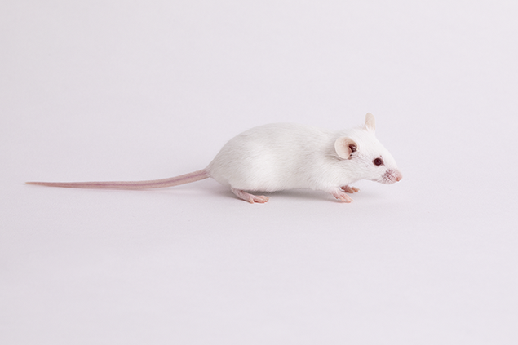

* JAX Swiss Outbred mice are an albino outbred stock (Swiss/ICR-derived from ARC, Australia) which produces large litters and may be useful in toxicology and pharmacology screens.
* Females are excellent mothers, producing litters with an average of 14 pups, and they may also be used as recipients for non-albino embryo transfers.
* These mice may be useful for toxicology and pharmacology screens.

**Price details\***

|  |  |  |  |  |
| --- | --- | --- | --- | --- |
| **AGE** | **Female** | | **Male** | |
| **Import price** | **Indian price** | **Import price** | **Indian price** |
| 3 Weeks | $31.83 |  | $36.51 |  |
| 4 Weeks | $32.98 |  | $39.36 |  |
| 5 Weeks | $34.11 |  | $42.19 |  |
| 6 Weeks | $35.25 |  | $45.03 |  |
| 7 Weeks | $36.40 |  | $47.88 |  |
| 8 Weeks | $37.55 |  | $50.71 |  |
| 9 Weeks | $38.68 |  | $53.56 |  |
| 10 Weeks | $39.83 |  | $56.39 |  |

**Body weight information\***

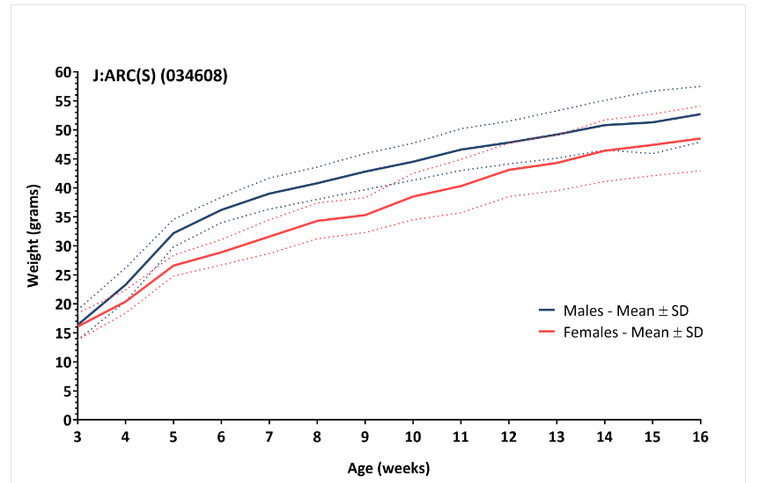

|  |  |  |
| --- | --- | --- |
| **Age (Weeks)** | **Body Weight (grams; mean± st. dev)** | |
| **Females** | **Males** |
| 3 | 16.4 ± 2.6 | 16.1 ± 2.3 |
| 4 | 23.3 ± 2.9 | 20.4 ± 2.0 |
| 5 | 32.2 ± 2.4 | 26.6 ± 1.8 |
| 6 | 36.2 ± 2.2 | 28.9 ± 2.2 |
| 7 | 39.0 ± 2.7 | 31.6 ± 2.9 |
| 8 | 40.8 ± 2.8 | 34.3 ± 3.1 |
| 9 | 42.8 ± 3.1 | 35.3 ± 3.0 |
| 10 | 44.5 ± 3.2 | 38.5 ± 4.0 |
| 11 | 46.6 ± 3.6 | 40.3 ± 4.6 |
| 12 | 47.8 ± 3.7 | 43.1 ± 4.6 |
| 13 | 49.2 ± 4.1 | 44.3 ± 4.8 |
| 14 | 50.8 ± 4.3 | 46.4 ± 5.3 |
| 15 | 51.3 ± 5.4 | 47.4 ± 5.3 |
| 16 | 52.7 ± 4.8 | 48.5 ± 5.6 |

* Price details and body weight information mentioned above are as per US considerations and Indian data is yet to be updated

1. **CRO services**

ATNT Laboratories India Private Limited provides a wide range of contract research organisation (CRO) services. We are on the front lines, ensuring that our goods, services, and processes keep up with the rapid advancement of science and technology, as well as the ever-changing requirements of your product development.

Various CRO services offered by our company include:

1. Research Models & Services
2. *In vitro* ADME Services
3. *In vivo* Pharmacokinetics (PK) Studies and Services
4. *In vivo*Pharmacology Studies and Services
5. Toxicology Services
6. Integrated Drug Discovery Preclinical CRO
7. Laboratory Pathology Services

## **Research Models & Services**

The selection of suitable and appropriate animal models is crucial for designing product development programmes.

ATNT Laboratories has experience in assessing the safety of compounds from all product sectors using both conventional rodent and non-rodent animal models.

Our extensive array of research models and services at ATNT Laboratories enables us to assist our clients in their research, discovery, and development of innovative therapeutics in the rapidly evolving world of biomedical science. Our global network of commercial breeding facilities; rigorous genetic standards; and core values of animal welfare, biosecurity, and the 3Rs uniquely position us to support your specific research needs.

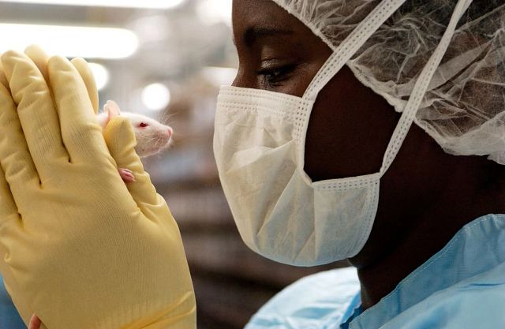

* 1. **Research Animal Models**
* High quality inbred, outbred, disease, germ-free and immunodeficient models
  1. **Genetically Engineered Models & Services**
* Contract breeding, model creation and embryology services
  1. **Research Animal Diagnostics**
* Diagnostic services, including environmental, microbiological, serology testing and more
  1. **Genetic Testing Services**
* Genotyping and other genetic quality testing/assays
  1. **Insourcing Solutions**
* Training, staffing and other support services, including facility management and vivarium rental

**1.1 Research Animal Models**

**Various animal species offered by our company include:**

* + 1. Rodent species
    2. Non- rodent species
    3. **Rodent species**

Rats and mice are the rodent species routinely used because of their susceptibility to toxic challenge, tumour induction, and carcinogenicity. In addition, we have a vast amount of background information available on their survival, physiology, pathology and susceptibility to different test items.

* + 1. **Non- rodent species**

In the past, rodents and small mammals have been studied using induced disease for human pharmaceuticals, biologics and devices. Many of these small mammal models fail or don’t translate well into humans. The pathway to registration for human use becomes long, expensive and complex.

Larger mammals (rabbits, minipigs, pigs, sheep, dogs, alpacas) are a similar size, have some shared physiology and have many diseases in common with humans. Using large mammal models may de-risk the registration pathway as they are more similar model to humans. Spontaneous disease in these animals can also be used to show that the human medicine, biologic or device is safe and effective.

Large animals have been widely used as translational models to satisfy regulatory requirements for testing in nonrodent species. We also conduct preclinical studies in the standard non-rodent species.

Various speciality study designs include:

* Safety pharmacology
* Developmental and reproductive toxicology
* Juvenile toxicology
* Ocular toxicology
* Bone and muscle toxicology
* Neurotoxicology
* Imaging
* Biomarkers

**Various large animals offered by our company include:**

1. Rabbits
2. Mini pigs
3. Dogs
4. **Rabbits**

The rabbit is a particularly useful animal model for assessing ocular and dermal irritation and is also the primary nonrodent species for developmental toxicity studies.

1. [**Minipigs**](https://www.criver.com/products-services/safety-assessment/preclinical-species/minipigs)

The minipig is becoming the model of choice in pharmaceutical development programs due to its physiological similarities in humans and availability. Consequently, regulatory authorities now accept the [minipig as a suitable nonrodent species](https://www.criver.com/resources/alternative-nonrodent-models-minipig-specialty-capabilities) for use in safety evaluation assessment and efficacy studies when it’s scientifically appropriate.

Our scientists have experience performing a wide range of study types in several minipig strains as well as full-size domestic swine. They are available to advise appropriate [study design](https://www.criver.com/source/optimizing-design-minipig-embryofetal-studies) for your research.

Our advanced technology and experienced staff are available to support you with the knowledge and resources you need to make better decisions and progress your lead compounds forward.

Our experience running a wide range of study types in several minipig strains means we can advise on the best design for your specific study. We also offer full-service laboratory support to enable each client to have all aspects of a study performed at a single GLP-compliant facility.

Various speciality study designs include:

* Teratology studies
* [Fertility assessments](https://www.criver.com/resources/interspecies-comparison-embryo-fetal-data-among-control-groups-sprague-dawley-rats-new-zealand-white)
* Juvenile studies
* Safety pharmacology studies
* Toxicokinetic (ADME) studies
* Wound healing studies
* Diabetic model

1. **Dogs**

Dogs have similar physiological and genetic similarities to people (80% of the genome is shared between the species). The variations in breeds, environments, diet and the lifestyle of dogs are more similar to the lifestyles of humans than those of laboratory rodents. Dog cancers respond to treatment (surgery, radiation and chemotherapy) in a similar way to people.

Various speciality study designs include:

* OSTEOARTHRITIS - This is a very common disease in dogs, and dogs are a particularly good model for this disease in humans. ATNT Laboratories has expertise in conducting GCP studies for osteoarthritis.
* PHARMACOKINETICS/PHARMACODYNAMICS

Certain cancers are microscopically and molecularly similar between dogs and humans (e.g. bladder, osteosarcoma, lymphoma), and the mutations that cause them are the same.

### Cancer types that are used in oncology studies are:

* Lymphoma (Non-Hodgkins Lymphoma)
* Osteosarcoma
* Glioblastoma and meningioma
* Melanoma
* Mammary tumours
* Solid tumours
* Hemangiosarcoma (angiosarcoma)
* Nasal Carcinoma

1. **[Surgical Models](https://www.criver.com/products-services/safety-assessment/preclinical-species/surgical-models)**

ATNT Laboratories offers a range of acute and chronic surgical models for use in any drug metabolism, pharmacology, or safety study type. Our research surgeons have extensive experience in the development of sophisticated surgical procedures in a variety of rodent and large animal species and are available to assist in the creation of the most relevant animal model for an enhanced understanding of your compound.

Various speciality study designs include:

* Proof-of-concept/Mechanism of action
* Safety and biodistribution
* Tumorigenicity
* Acute chronic toxicity
* Targeted delivery

Various therapies include:

* Small molecule
* Large molecule
* Cell therapies
* Gene therapies
* Medical device
* Combination products

## ***In vitro* ADME Services**

Drug discovery at every stage is catered by *in vitro* ADME tests, which include both customised and stand-alone assays.

We are able to customise study designs based on customer requirements and validate ADME assays that are currently in use. With their exceptional troubleshooting skills, our team of scientists meets the ADME requirements. We have experience in handling small molecules, therapeutic peptides and complex molecules.

* 1. **Physiochemical Properties**
* Solubility and chemical stability at different pH, SIF and SGF
* Solubility: Kinetic, thermodynamic, HT Log D
  1. **Permeability**
     + - Caco-2 Bi-directional permeability, Efflux ratio MDCK, MDCK-LE, MDCK-MDR1, MDCK-BCRP permeability PAMPA
  2. **Distribution**
     + - Plasma Protein, *in vitro* Tissue binding
       - Blood to plasma partition
       - Brain to plasma partition
  3. **Metabolism**
     + - Microsomal Clearance, S9, Phase I/Phase II, Hepatocyte Clearance
       - Plasma/ Whole Blood Stability CYP Phenotyping
  4. **Drug-Drug Interactions**
     + - CYP Inhibition, CYP TDI, kobs
       - CYP Induction
       - P-gp and BCRP Inhibition & Substrate Identification

## ***In vivo* Pharmacokinetics (PK) Studies and Services**

We provide *in vivo* pharmacokinetic studies using wide range of administration routes.

Our pharmacokinetic (PK) studies on mice, rats, and dogs aids in understanding the characteristics of New chemical entities (NCEs). Our PK studies are quite effective in predicting the exposure along with determining dosages and testing intervals for preclinical *in vivo* animal disease efficacy models. Our DMPK experts contribute to your understanding of the drug's volume of distribution, Cmax, Cmin, and AUC throughout time in the body.

**3.1 PK In Rodents (Rats/ Mice)**

* Single or Multiple dose
* Discrete or Cassette
* Micro sampling
* Cross-over or non-cross-over design
* Dose escalation studies
* Food effect, Gender effect

**3.1.1 Surgical Models (Cannulations)**

* Single or double Jugular vein
* Tail vein
* Duodenum
* Bile duct
* Femoral vein

**3.1.2 PK In Other Matrices (Rodents)arrow**

* Tissue distribution
* Brain penetration
* PK in CSF, Spinal cord, Sciatic nerve
* Testes PK
* Excretion studies

**3.2 PK In Dogsarrow**

* Single or multiple dose PK
* Non-terminal studies

### **3.2.1 Route of Administrationarrow**

* Oral
* Intravenous (IV)
* Intramuscular (IM)
* Subcutaneous (SC)
* Intraperitoneal (IP)
* Dermal

## ***In vivo* Pharmacology Studies and Services**

To assess a drug's complicated physiological effects in a living creature, in vivo pharmacology is crucial. ATNT Laboratories provides in vivo pharmacology studies to evaluate the efficacy and early toxicity of small compounds and large molecules. With our expertise in multiple therapeutic areas, target-specific models, and group of highly experienced scientists, we are a productive partner for *in vivo* pharmacology services.

Our expanding disease models include:

* Pain models and Measurements
* Inflammation & auto immune diseases
* Metabolic disorders
* Oncology

### **Pain Models and Measurementsarrow**

ATNT Laboratories has successfully collaborated with the world’s top pharmaceutical companies for pain drug discovery. Our expertise and experience allow us to offer an extensive portfolio of services supporting drug discovery and development. We match the industry’s needs in the domains of:

* Acute and chronic inflammatory pain
* Visceral pain
* Arthritic pain
* Neuropathic pain

| **Type​** | **Animal Model** | **Species/ strain​** | **Validation standard​** |
| --- | --- | --- | --- |
| Acute Models | Acetic acid induced writhing | Male Swiss albino mice​ | Indomethacin/Tramadol​ |
| Carrageenan-induced mechanical hyperalgesia ​ | Male Wistar rat​ | Celecoxib​ |
| Complete Freund’s adjuvant (CFA) induced thermal hyperalgesia | Male Sprague Dawley rat​ | Indomethacin​ |
| Arthritic Pain​ | CFA-induced mono arthritis pain​ | Male Sprague Dawley rat​ | Naproxen​ |
| Monoidoacetate-induced osteoarthritis pai​n | Male Sprague Dawley rat ​ | Diclofenac​ |
| Neuropathic Pain | Partial sciatic nerve ligation​ | Male Wistar rat​ | Gabapentin ​ |

### **Inflammation and Auto-Immune Disordersarrow**

Our team of experts have developed in vivo models for autoimmune and inflammatory diseases. We offer inflammation animal models associated with:

* Neurological diseases
* Respiratory diseases
* Arthritis
* Skin diseases
* Gastrointestinal diseases

| **Type​** | **Animal Model** | **Species/ strain​** | **Validation standard​** |
| --- | --- | --- | --- |
| Acute Models | LPS-induced systemic inflammation (Plasma TNF-α) | Female wistar rat/ Male BALB/c mice​ | Roflumilast / Theophylline​ |
| LPS-induced systemic inflammation (Plasma IL-17)​ | Male C57BL/6 mice​​ | Digoxin​ |
| LPS-induced paw edema​ | Female wistar rat​ | Nimesulide |
| Carrageenan-induced paw edema​ | Male wistar rat​​ | Celecoxib​ |
| Acute Arthus reaction​ | Female C57BL mice​ | Kinase inhibitor​ |
| The SCF-induced systemic histamine release model​ | Female BALB/c mice​ | Anti C-KIT antibody |
| Mouse passive cutaneous anaphylaxis model​ | Female C57BL/6 mice​ | Dexamethasone |
| TNF + Zvad induced hypothermia​ | Female C57BL mice | Kinase inhibitor |
| Arthritis | Collagen-Induced Arthritis (Prophylactic)​ | Female Lewis rat​ | Leflunomide​ |
| Collagen-Induced Arthritis (Therapeutic)​​ | Female Lewis rat​ | Enbrel, Dexamethasone​​ |
| Adjuvant-Induced Arthritis (Prophylactic)​​​ | Female Lewis rat​ | Celecoxib​ |
| Medial Meniscus Induced Tear Osteo Arthritic model​ | Female Lewis rat​ | Celecoxib​​​ |
| Dermatitis & Psoriasis | DNFB-induced contact dermatitis ​​ | Female CD1 mice​ | Leflunomide​ ​ |
| Oxazolone-induced contact dermatitis​ | Male SD rat​ | Dexamethasone |
| Imiquimod-induced psoriasis model​​ | Female Balb/c mice​ | Dexamethasone /Anti mouse IL-17 anti body |
| IL-23-induced dermatitis model​ | Female Balb/c mice​​ | Tofacitinib/​ |
| Colitis | Dextran Sulphate Sodium induced colitis​ | C57BL/6 mice​​​ | cyclosporin​​ |
| Trinitrobezene sulphonic acid-induced colitis ​ | Female wistar rat/ BALB/c mice​ | Dexamethasone |
| Fibrosis | Unilateral ureteral obstruction model​ | Male C57BL/6 mice | Necrostatin-1​ |
| Acne​ | Hamster ear sebaceous gland model​ | Female Hamsters​ | spironolactone​ |
| Asthma​ | Ovalbumin/LPS induced neutrophilic asthma model​ | Male C57BL/6 mice​ | Digoxin​ |
| MS​ | MOG-induced EAE model in C57BL/6​ | Female C57BL/6 mice​ | Copaxone |

### **Metabolic Disorders (Diabetes, Obesity and Atherosclerosis)arrow**

The team has vast experience in conducting customized metabolic disorder animal models.

| **Type​** | **Strain-Species** | **Activity/test Model​​** | **Validating/Standards​​** |
| --- | --- | --- | --- |
| MD​ (Diabetes and Obesity) | Mice and rats​ | OGTT, IPGTT, IVLTT, and Euglycemic clamp study​​ | Pioglitazone/Exenatide​ |
| Swiss albino mice / Wistar rats/CD1 mice​​ | Acute food intake modulating activity ​ | Rimonabant/ PYY 3-36/Liraglutide |
| CD1 mice​ | 3 days of administration of food intake and body weight lowering activity​ | PYY 3-36​ |
| db/db mice​ | Blood glucose lowering and anti-dyslipidemic activity | Pioglitazone/ liraglutide |
| Zucker fa/fa rats | Anti-dyslipidemic activity and insulin-sensitizing activity​ | Fenofibrate/Pioglitazone​ |
| ob/ob mice​ | Body weight lowering and insulin-sensitizing activity​​ | Metformin/Pioglitazone |
| C57BL/6 - DIO mice | Body weight lowering activity​ | Rimonabant/PYY 3-36 |
| CV (Atherosclerosis) | LDLr -/-Mic | Anti-atherosclerotic activity​ | Fenofibrate​ |
| Swiss albino mice | Lipid-lowering activity | Fenofibrate ​​ |
| High-fat-fed Sprague Dawley rats | Acute lipid (TC, TG) lowering activity​ | Fenofibrate |
| Golden Syrian Hamster | HDL elevating activity​ | Torcetrapib ​ |

### **Oncology Animal Model**

ATNT Laboratories has significant experience in oncology drug discovery. We offer a large collection of tumour models for small and large molecule drug discovery.

| **Cancer type ​** | **Cell line​** | **Mice ​​​** | **Model type ​​** |
| --- | --- | --- | --- |
| Lung cancer, NSCLC | A549, Known to be KRAS mutant and EGFR wild type ​ | Ncr nude mice​​ | Xenograft, subcutaneous​ |
| Multiple Myeloma ​ | H929​​ | NOD SCID mice ​ | Xenograft, subcutaneous​ |
| Breast cancer​ | MCF-7 cells are ER+, progesterone receptor-positive, and HER2 negative.​​ | Ncr nude mice ​​​ | Xenograft, subcutaneous​ |
| Prostate cancer​ | 22RV1, cell line has been derived from a human prostatic carcinoma xenograft, CWR22R | Ncr nude mice | Xenograft, subcutaneous​ |
| Colon cancer​ | COLO 205 non metastatic ​​ | Ncr nude mice​​ | Xenograft, subcutaneous​ |
| Leukemia​ | MV-4-11, human biphenotypic B myelomonocytic leukemia​​​ | Ncr nude mice | Xenograft, subcutaneous​​ |
| Colon cancer​ | CT26​​ | BALB/c mice | Syngeneic, subcutaneous​      Established model ​ |
| Ovarian cancer​ | SKOV-03​​ | Ncr nude mice | Xenograft, subcutaneous      Established model​ |
| Acute myeloid leukemia​ | MOLM-13​​ | NOD SCID mice | Xenograft, subcutaneous      Established model​ |

### **Miscellaneous Models**

* Mouse/ rat whole blood and splenocyte assays with different stimulants (LPS, NECA) and evaluation of cytokines and biomarkers using flow cytometer.
* Oxidative stress markers evaluation in rats administered with repeat intravenous Iron formulation.
* Evaluation of test compounds potential in modulating serum Iron and hepcidin expression modulation in restricted iron diet fed rats.
* Evaluation of test compounds potential in muscle regeneration in thermal injury mice model.
* Anti-acne potential evaluation of test compounds in hamsters ear sebaceous gland model.
* Evaluation of test compounds efficacy in mice post-operative ileus model.
* Evaluation of test compounds efficacy in gastric emptying and intestinal motility in mice model

## **Toxicology Services**

ATNT laboratories offers a large array of GLP and non-GLP preclinical toxicology studies to its customers. The studies, in which our toxicology services team has expertise, comprise of acute, sub-acute, sub-chronic studies in various test systems with different routes of administration. These studies are performed in compliance with global regulatory guidelines, ICH, OECD, etc. We guarantee timely and accurate communication across time zones by streamlining workflows, processes, and communication technologies.

Various toxicological services provided by our company include:

* 1. General toxicity studies

## Genetic Toxicity Studies

## Reproductive Toxicology

## **General Toxicity Studies**

Toxicity studies using mammalian species are generally required to provide safety data to support clinical development and licencing registration for potential new pharmaceuticals. ATNT Laboratories offers a complete range of standard toxicology studies designed for supporting submissions to various regulatory agencies. Equipped with multiple test species including rodents and non-rodents (Beagle dogs, rabbits and Mini pigs), our studies are closely supervised by the Study Directors who have vast experience of performing GLP studies spread across different disease therapies for domestic and international pharmaceutical and biotechnology companies. This not only results in delivery of high-quality data accompanied with proper interpretation, but ensures that each aspect of your study is thoroughly reviewed and reported.

Preclinical toxicology studies are a key component of drug development because they help to evaluate the drug's potential safety and toxicity before it is evaluated in human clinical trials. These studies are critical in determining the appropriate dose range for a drug and can provide information regarding its potential side effects and adverse reactions.

Our team can rapidly identify potential risk factors early in the drug development or agrochemical registration process since we have a strong mechanistic understanding of toxicology. Many of our scientists have served on, or are currently participating in, regulatory and industry body working groups, shaping the future of our studies.

### **Various Toxicology Services offered by our company include;**

* [Non-GLP Acute Toxicology Studies](https://www.criver.com/products-services/safety-assessment/toxicology-services/non-glp-acute-toxicology)
* [Ocular Toxicology](https://www.criver.com/products-services/safety-assessment/toxicology-services/ocular-toxicology)
* [Infusion Toxicology](https://www.criver.com/products-services/safety-assessment/toxicology-services/infusion-toxicology)
* [Inhalation Toxicology](https://www.criver.com/products-services/safety-assessment/toxicology-services/inhalation-toxicology)
* [Musculoskeletal Toxicology](https://www.criver.com/products-services/safety-assessment/toxicology-services/musculoskeletal-toxicology)
* [Neurotoxicology](https://www.criver.com/products-services/safety-assessment/toxicology-services/neurotoxicology)
* [Abuse and Dependence Liability Testing](https://www.criver.com/products-services/safety-assessment/toxicology-services/neurotoxicology/abuse-dependence-liability-testing)
* [In Vitro Toxicology](https://www.criver.com/products-services/safety-assessment/toxicology-services/vitro-toxicology)
* [Ocular Irritation Models](https://www.criver.com/products-services/safety-assessment/toxicology-services/ocular-irritation-models)
* [Ototoxicity Testing](https://www.criver.com/products-services/safety-assessment/toxicology-services/ototoxicity-testing)
* [Infectious Disease Models](https://www.criver.com/products-services/safety-assessment/toxicology-services/infectious-disease-models)
* [Phototoxicity Testing](https://www.criver.com/products-services/safety-assessment/toxicology-services/phototoxicology)
* [Skin Irritation, Corrosion and Sensitization](https://www.criver.com/products-services/safety-assessment/toxicology-services/skin-irritation-corrosion-and-sensitization)
* [REACH Services](https://www.criver.com/products-services/safety-assessment/toxicology-services/reach-services)
* [Field Trials](https://www.criver.com/products-services/safety-assessment/toxicology-services/field-trials)
* [Human Exposure Studies](https://www.criver.com/products-services/safety-assessment/toxicology-services/human-exposure-studies)
* Radiation Biology
* Seizure Liability Testing
* [Genomic Services](https://www.criver.com/products-services/lab-sciences/molecular-biology/genomics-services)

### **Routes of Administration**

* Dermal
* Implant
* Inhalation
* Intraarticular
* Intranasal
* Intrathecal
* Intravaginal and intrapenile
* Intravesicular
* Ocular
* Oral (gavage, diet and capsule)
* Parenteral (intravenous, subcutaneous, intradermal, intramuscular and

intraperitoneal)

* Rectal
* Infusion (bolus, intermittent, continuous)
  + 1. **Rodents (Rats and mice)**

Various study designs where rats and mice were used include:

* Acute (24 to 96 hrs.)
* Sub-chronic (28 to 90 days)
* Chronic (90 days to 6 months)
* Developmental and reproductive
* Juvenile
* Carcinogenicity (14 days to 24 months)

**5.1.2 Non-Rodents (Beagle dogs, rabbits and Mini pigs)**

Various study designs where non- rodents were used include:

* 90-day repeat dose toxicology studies
* 9- month repeat dose toxicology studies

## **Genetic Toxicity Studies**



Genetic toxicology studies are conducted during early stages of the safety testing program of pharmaceutical and biotechnology products. ATNT Laboratories conducts genetic toxicology studies in a tiered approach, starting with an Ames test and progressing to the conduct of mammalian cell and *in vivo* assays, which are designed to assess the toxicological relevance of any earlier observations. Our genetic toxicology capabilities include:

* Bacterial reverse mutation assay (Ame’s test)
* *In vitro* mammalian cell gene mutation test in mouse lymphoma cells using the Tk gene and in CHO cells using the Hprt gene
* *In vitro* mammalian chromosomal aberration test using human peripheral blood lymphocytes (HPBL), V79 cells and CHO cells
* *In vitro* micronucleus test in human peripheral blood lymphocytes (HPBL) and CHO cells
* *In vivo* micronucleus test in rat and mouse
* *In vivo* chromosomal aberration

## **Reproductive Toxicology**

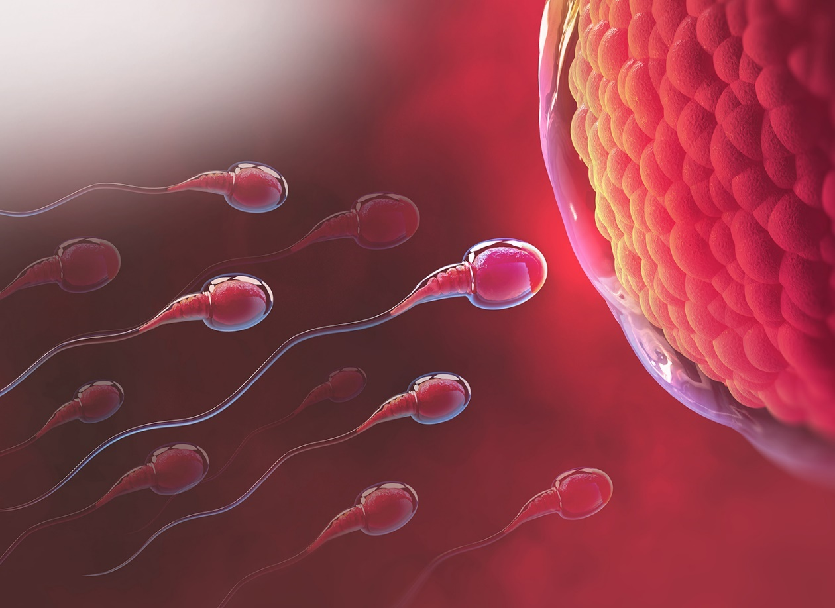

The reproductive toxicology studies are carried out primarily to assess the possible effects of drugs on reproductive performance and fertility.

The developmental and reproductive toxicology team at ATNT Laboratories is well-equipped with the latest technologies and possesses the necessary knowledge to handle a wide range of demands for these types of research, including those involving neonatal and juvenile animal studies. The studies are designed to test the effect of drugs including small molecules and biologics on fertility, embryo foetal development, prenatal and postnatal development and maternal function. We also conduct studies for identification of endocrine disruptor functions, which include determination of serum hormone levels, oestrous cycling, uterotrophic and Hershberger assays, uterine and vaginal histopathology and cell staging.

Our key services and capabilities include:

* Fertility (Male and / Female) – Segment I
* Embryo-foetal Development – Segment II
* Prenatal and Postnatal Development, including Maternal Function – Segment III
* Neonatal and Juvenile Toxicity Studies
* Reproductive and Developmental Toxicity Screening Studies
* Combined Repeated Dose Toxicity Studies with Reproduction and Developmental Toxicity Screening
* One Generation Reproduction Toxicity Studies
* Two Generation Reproduction Toxicity Studies
* Extended One Generation Reproduction Toxicity Studies
* Developmental Neurotoxicity Studies

***In Vivo* specialty studies for Endocrine-Disrupting Chemicals**

* Uterotrophic Bioassay in Rodents
* Hershberger Bioassay in Rodents

## **Integrated Drug Discovery Preclinical CRO**

The average industry timescale from hit identification to preclinical candidate nomination is 33-36 months. As a full-service preclinical drug development CRO with an integrated approach to development, ATNT laboratories can reduce this timeline to as little as 24 months. We reduce time to market by utilising multidisciplinary teams with industry experience that prioritise scientific excellence, resource efficiency, and strategic relationships.

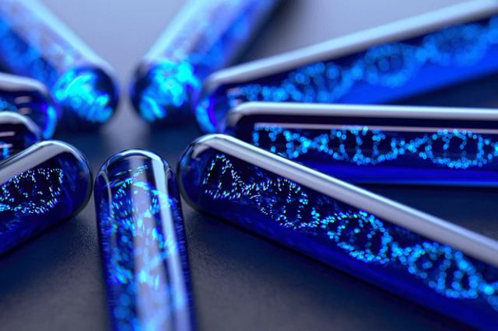

Our preclinical scientists are knowledgeable advisors with experience in nearly every therapeutic area for drug development. They are able to provide preclinical development candidates that fit your intended product profile by understanding your requirements.

By selecting ATNT laboratories as your preclinical drug development CRO, you may advance compounds from hit identification to lead optimisation and development using a knowledge-based strategy that will benefit your programme. Our team continuously turns leads into candidates by combining innovative technologies with decades of experience.

## **Laboratory Pathology Services**

When selecting CRO laboratory pathology services, choosing a trusted partner is critical to your program’s success. Preclinical and clinical investigations with the objective to determine the safety, effectiveness, and mode of action of novel therapeutic drugs must include a comprehensive evaluation of pathologic alterations. We have the pathologic knowledge to advance your study, whether your efforts are investigative or regulatory.

ATNT laboratories have senior veterinary pathologists, who have actively participated in formal quality assessment and peer review programs. Our pathologists have amassed many years of combined experience and expertise spanning all organ systems, therapeutic areas, administration routes, and techniques ranging from routine histopathology to specialty services such as immunohistochemistry, electron microscopy, and more.

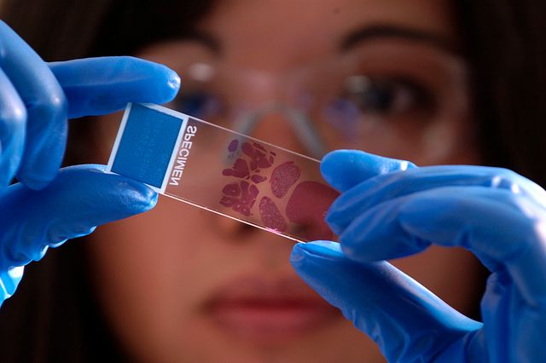

* Top of Form
* Bottom of Form

Take use of our wide network of pathologists to assist you in the areas of multidisciplinary pathology as listed below.

* Clinical pathology
* Digital pathology Services
* Immunohistochemistry (IHC) Services
* In Situ Hybridization (ISH) Services
* Electron Microscopy Services
* Toxicologic Pathology
* Musculoskeletal Pathology
* Neuropathology
* Developmental & Reproductive pathology
* Ocular Pathology services
* Medical Device pathology

## **Minimum Inhibitory (MIC) and Minimum Bactericidal Concentration (MBC) Testing Services**

ATNT Laboratories provides expertise in antibiotic susceptibility testing services. We provide a wide range of antibiotic susceptibility testing services such as Minimum Inhibitory Concentration (MIC) and Minimum Bactericidal Concentration (MBC) tests in accordance with the guidelines issued by the Clinical and Laboratory Standards Institute using broth micro dilution, broth macro-dilution, disk diffusion and agar dilution methods.

* 1. **Minimum Inhibitory Concentration (MIC)**

The MIC testing services for New Chemical Entity (NCE) helps determine the lowest concentration of an antimicrobial agent that prevents visible growth of a microorganism under defined test conditions.

We use the MIC values to evaluate the activity of new antimicrobial agents and to determine the NCE’s susceptibilities of microorganisms. MIC is considered as the ‘gold standard’ for determining the susceptibility of organisms to antimicrobials and is therefore used to judge the performance of all other methods of susceptibility testing.

Cultured microbes are incubated with the NCE at various concentrations and measured for the results using agar dilution or broth dilution methodology to determine the MIC endpoint. Agar dilution involves incorporating different concentrations of the antimicrobial substance into agar medium followed by the application of a standardized number of cells to the surface of the agar plate. For broth dilution, we often determine it in 96-well micro titer plate format, where microorganisms are inoculated into a liquid growth medium in the presence of different concentrations of an antimicrobial agent. Growth is assessed after incubation for a defined period of time (16–20 hours).

Susceptibility testing is typically conducted using organisms that contribute to an infectious process warranting antimicrobial chemotherapy. Several microorganisms such as aerobic or anaerobic bacteria, yeasts can be tested based on the requirement.

* 1. **Minimum Bactericidal Concentration (MBC)**

The MBC testing services help to determine the lowest concentration of an antimicrobial agent required to achieve bactericidal killing defined at 99.9% reduction in the initial inoculum. We chose it by sub-culturing broth dilution concentrations that inhibit the growth of a bacterial organism i.e. concentrations at and above the MIC. The broth dilutions are streaked onto agar surface and incubated for 24 to 48 hours. MBC is the lowest broth dilution of antimicrobial that prevents the growth of the organism on the agar plate. Failure of the organism to grow on the agar plate implies that all viable microorganisms have been eliminated.

## **Environmental Safety**



Global regulatory authorities demand that businesses carry out an adequate testing programme prior to approval due to the growing risk that pharmaceuticals, biocides, industrial chemicals, and agrochemicals create when they are released into the environment. ATNT Laboratories has extensive experience in environmental risk assessments, including those for veterinary pharmaceuticals (Environmental Impact Assessment).

Depending on the product and target market, environmental safety and risk testing can be a lengthy and time-consuming procedure that takes several years. Conducting an integrated environmental testing program with ATNT Laboratories reduces the potential for unexpected hurdles to hinder your path to registration. Offering a comprehensive range of testing services, including [ecotoxicology](https://www.criver.com/products-services/safety-assessment/environmental-safety/ecotoxicology-studies), [environmental fate](https://www.criver.com/products-services/safety-assessment/environmental-safety/environmental-fate-efate-studies?region=3696), and [endocrine disruptor screening](https://www.criver.com/products-services/safety-assessment/environmental-safety/endocrine-disruptor-screening-program?region=3696), as well as [field trials](https://www.criver.com/products-services/safety-assessment/toxicology-services/field-trials?region=3696), [human exposure](https://www.criver.com/products-services/safety-assessment/toxicology-services/human-exposure-studies?region=3696) and [residue chemistry](https://www.criver.com/products-services/lab-sciences/formulation-product-chemistry/residue-analysis?region=3696), we also prepare expert reports containing risk assessments, proposed testing strategies or considerations for waiving certain requirements.

ATNT Laboratories offers a broad portfolio of studies necessary to carry out complete safety evaluation programmes. The company is skilled in creating customised study programmes to meet the regulatory requirements of new products and their intended markets. Our global laboratory and animal facilities offer a wide range of study designs including product chemistry, toxicology, metabolism, environmental studies, field trials, residue analysis and human exposure studies.